**BUSINESS PROBLEM**

Over the past few years, both city hotels and resort hotels have encountered significant challenges due to elevated cancellation rates. These challenges encompass issues such as reduced revenues and suboptimal utilization of hotel rooms. Hence, the primary objective for both hotels is to minimize cancellation rates, aiming to enhance efficiency, boost revenues, and provide valuable business insights to tackle this issue. The report delves into the analysis of hotel booking cancellations, along with exploring various factors unrelated to their business that impact yearly revenue generation.

**ASSUMPTIONS**

1. The data used will not be significantly affected by any unexpected events between 2015 and 2017.
2. The information remains up-to-date and can efficiently contribute to the analysis and planning of hotels.
3. There are no unforeseen drawbacks to the hotel adopting the recommended techniques.
4. The suggested solutions are not currently implemented by the hotels.
5. The most significant factor influencing the effectiveness of income generation is the cancellation of bookings.
6. Cancellations lead to vacant rooms for the respective period.
7. Clients tend to make hotel reservations in the same year as their cancellations.

**Research Question**

1.What factors contribute to the cancellation of hotel reservations?

2.How can we enhance the hotel reservation cancellation process?

3.In what ways can hotels receive support in optimizing pricing and promotional decisions?

**Analysis and finding**

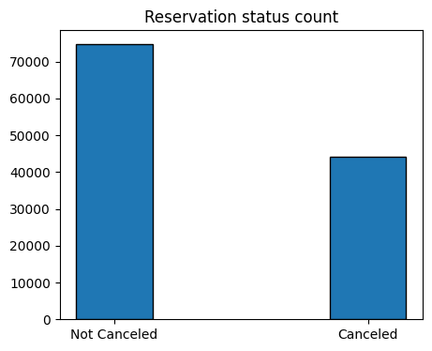

The accompanying bar graph illustrates the percentage of reservations that have been cancelled versus those that have not. It is evident that a substantial number of reservations remain unaffected, with 37% of clients having cancelled their bookings. This has a noteworthy impact on the hotel's earnings.

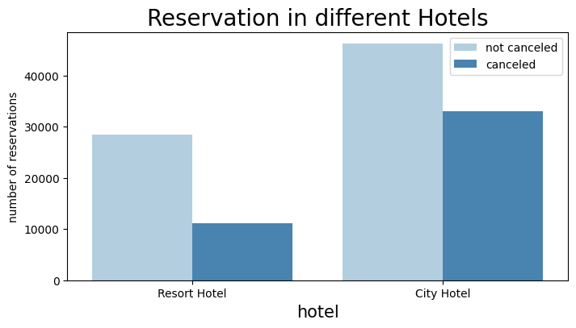

In contrast to resort hotels, city hotels experience higher cancellation rates, potentially due to their higher cost.

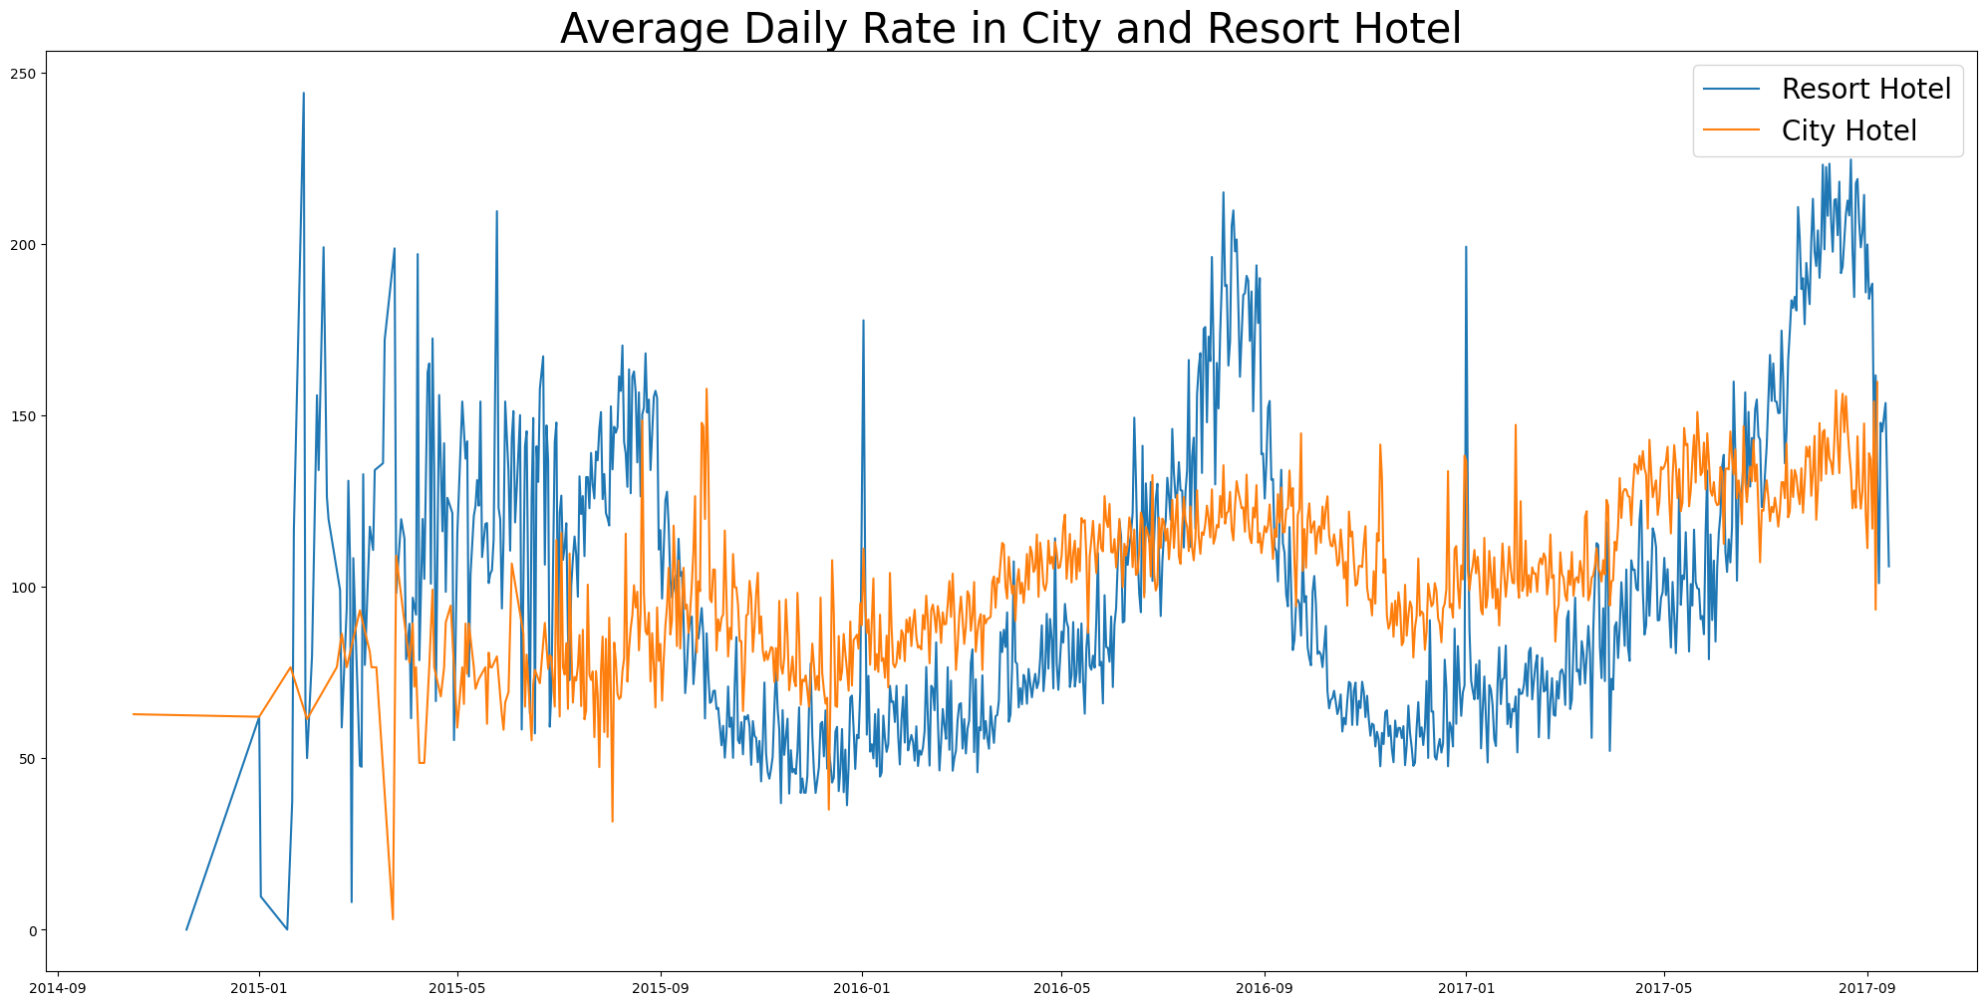

The line graph illustrates that, on specific days, the average daily rate of a city hotel is lower than that of a resort hotel, and on other days, it is even more pronounced. It is evident that weekends and holidays may contribute to an increase in resort hotel rates.

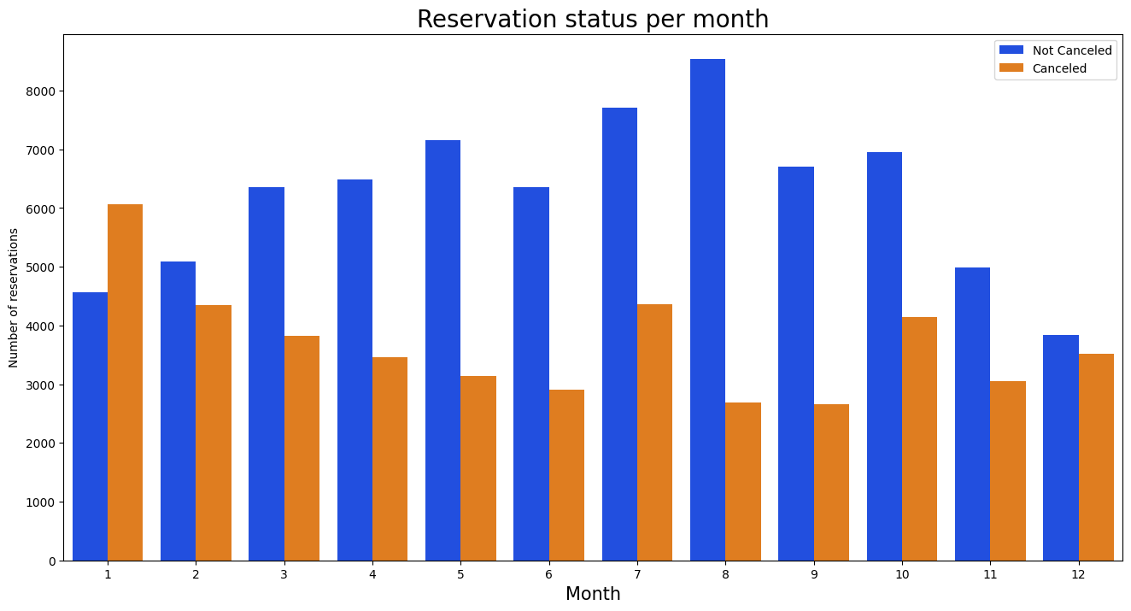

We created a grouped bar graph to analyze the months with the highest and lowest reservation levels based on reservation status. It is evident that both the number of confirmed reservations and the number of canceled reservations peak in the month of August. Conversely, January has the highest count of canceled reservations.

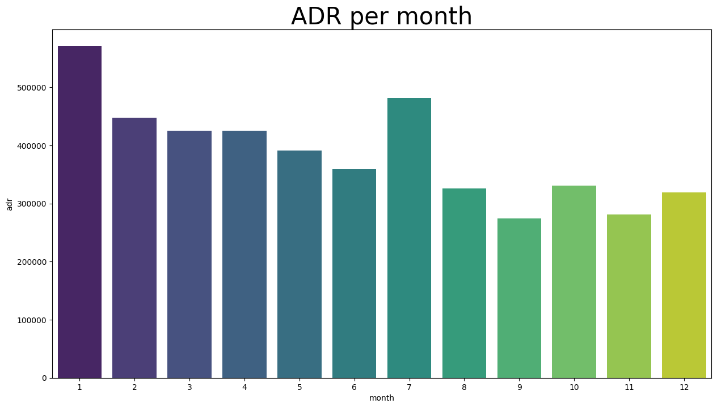

The bar graph illustrates that cancellations are most frequent when prices are at their highest and least common when they are at their lowest. Hence, the cost of accommodation appears to be the primary factor influencing cancellations.

Now, let's examine which country has the highest number of reservation cancellations. Portugal emerges as the top country with the highest number of cancellations.

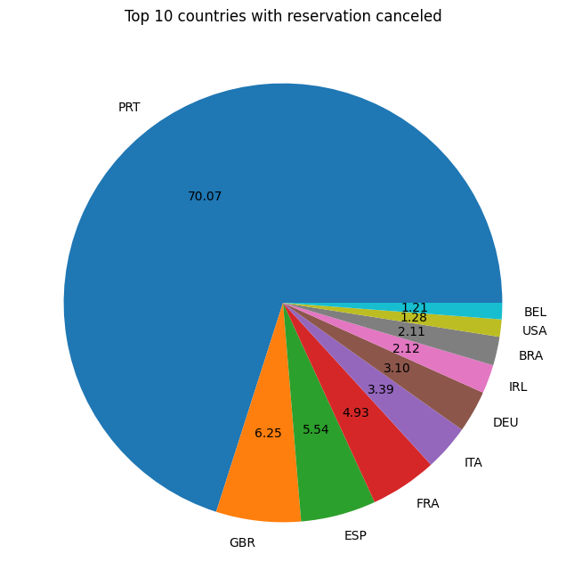

Let's explore the sources from which guests are making reservations, whether through direct channels, groups, online travel agents, or offline travel agents. Approximately 40% of the clients choose online travel agents, while around 27% come through group reservations. Only 4% of clients opt for direct bookings by visiting the hotel.

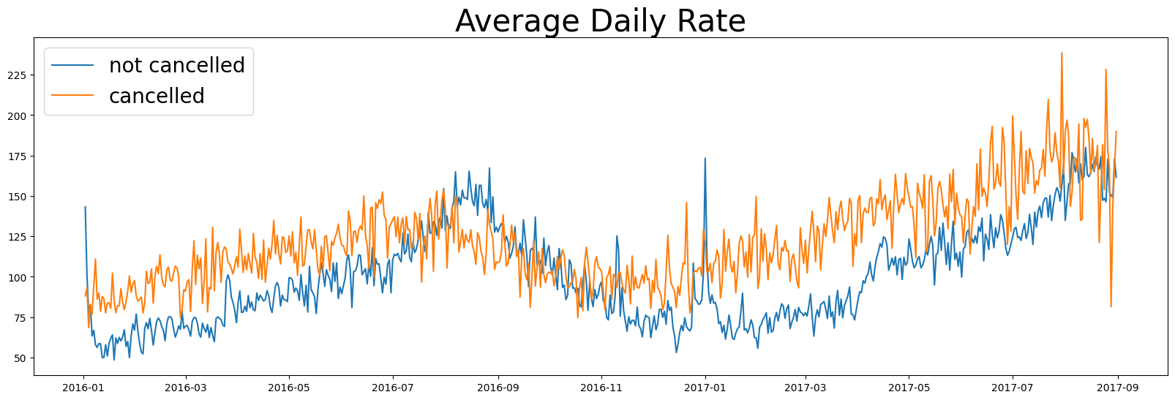

The graph illustrates that cancellations tend to occur when the average daily rate is higher compared to instances when it is not cancelled. This observation strongly supports the previous analyses, highlighting that higher prices correlate with increased cancellation rates.

**SUGGESTION**

1. Cancellation rates exhibit an upward trend with the increase in prices. To mitigate reservation cancellations, hotels may consider refining their pricing strategies, potentially lowering rates for specific hotels based on their locations. Offering discounts to consumers could also be an effective approach.

2. The proportion of cancellations to non-cancellations is higher in resort hotels compared to city hotels. To address this, hotels might consider implementing reasonable discounts on room prices during weekdays and holidays.

3. Launching campaigns or marketing initiatives with attractive offers in January could be a strategic move for hotels to boost revenue, considering that cancellations are highest during this month.

4. Elevating the quality of hotels and services, especially in Portugal, could contribute to a reduction in cancellation rates. Enhancing the overall guest experience may foster loyalty and decrease the likelihood of cancellations.